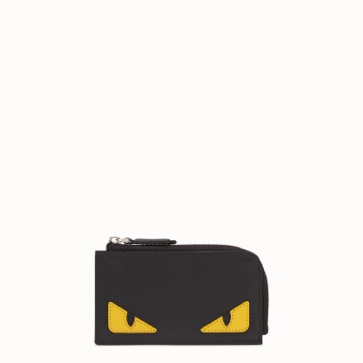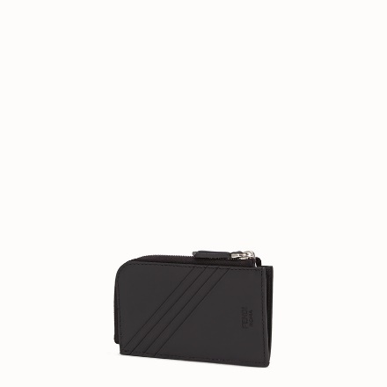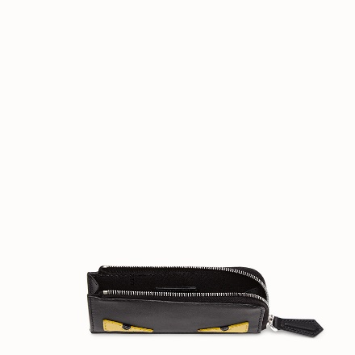

FENDI-COIN PURSE

$490.00

COLOR :BLACK/RED  
SIZE : ONE SIZE  
IN STOCK

[Detail](file:///D:\\Final\\Tong%20hop%20Fendi\\fendi_2m\\fendi2.html" \l "collapse)

Coin purse with gusseted sides. Zip fastening on two sides. Made of black calfskin. Yellow leather appliqués in the shape of Bag Bugs eyes.Made in Italy.

• Length:8.5 inches

• Height:3.9 inches

• Depth:0.8 inches

• Composition:100% Lamb leather + back: 100% Calf

Universal Style #: Product Code:7M0270O73F17HQ

[CARE & COMPOSITION](file:///D:\Final\Tong%20hop%20Fendi\fendi_2m\fendi2.html#collapse1)

• Leather

• Imported